Project 4: SIEM Detection Engineering, Alert Triage & SOC Operations
3. Requirements Gathering
This section identifies the main stakeholders of the SIEM/SOC system and describes how users are expected to interact with the system through user stories and use cases.
3.1 Stakeholder Analysis
Stakeholder analysis identifies the people and teams who use, manage, or are affected by the SIEM and SOC operations.
Stakeholder | Role in the Project | Main Needs
SOC Analyst | Monitors SIEM alerts, investigates suspicious activities, performs alert triage, and escalates confirmed incidents. | Clear alerts, centralized logs, useful dashboards, threat intelligence, and enough context to investigate an alert.
SOC Manager | Supervises SOC operations and monitors the overall performance of the security team. | Security KPIs, alert statistics, MTTD, MTTR, closure rate, and incident trends.
Incident Response Team | Handles serious or confirmed security incidents after escalation from the SOC. | Detailed incident information, affected systems, IOCs, investigation evidence, and timeline.
Network Administrator | Manages the organization's network infrastructure and provides network-related logs. | Network activity, suspicious connections, source/destination IPs, and network security alerts.
System / Endpoint Administrator | Manages servers and endpoint devices and supports investigations involving them. | Endpoint events, authentication activity, suspicious processes, and affected devices.
IT / Identity Administrator | Manages user accounts, authentication, and access-related systems. | Login activity, failed/successful authentication, privileged accounts, and account changes.
Security / IT Management | Reviews the security status of the organization and makes high-level decisions. | Major incidents, security trends, SOC performance, and summarized reports.

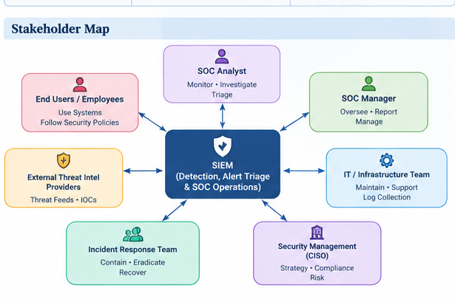
Stakeholder Map
3.2 User Stories & Use Cases
The following user stories and use cases describe the main interactions between SOC users and the SIEM system. They are based directly on the project's objectives: log monitoring, detection, alert triage, threat intelligence, dashboards, SOAR, and AI-assisted analysis.
3.2.1 User Stories
ID | User Story
US-01 | As a SOC Analyst, I want to view logs from different security sources in one SIEM, so that I can investigate security events centrally.
US-02 | As a SOC Analyst, I want to receive an alert when multiple failed login attempts occur, so that I can detect possible brute-force attacks.
US-03 | As a SOC Analyst, I want to detect suspicious login behavior, so that I can identify potentially compromised accounts.
US-04 | As a SOC Analyst, I want the SIEM to correlate related events, so that I can detect activities such as lateral movement and persistence.
US-05 | As a SOC Analyst, I want each alert to contain useful information such as source IP, destination IP, username, timestamp, and severity, so that I can investigate it quickly.
US-06 | As a SOC Analyst, I want to enrich suspicious IPs, domains, and hashes with threat intelligence, so that I can determine whether they are malicious.
US-07 | As a SOC Analyst, I want to classify alerts as true positive or false positive, so that I can focus on real security incidents.
US-08 | As a SOC Manager, I want a dashboard showing MTTD, MTTR, alert volume, closure rate, top attackers, and top targets, so that I can monitor SOC performance.
US-09 | As an Incident Responder, I want escalated alerts to include investigation details, so that I can continue the incident response efficiently.
US-10 | As a SOC Analyst, I want an automated response workflow for common incidents, so that repetitive response actions can be handled consistently.
US-11 | As a SOC Analyst, I want AI to summarize an alert and suggest investigation questions, so that I can investigate alerts faster.

Use Case Diagram
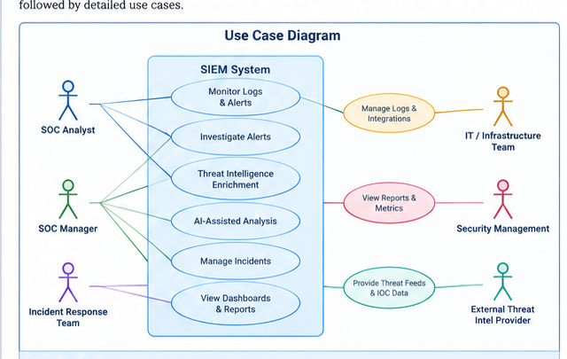
3.2.2 Use Cases
UC-01: Monitor Security Logs
Primary Actor: SOC Analyst
Goal: View and search centralized security logs in the SIEM.
Main Flow:
1. The SIEM receives logs from configured sources.
2. The analyst opens the SIEM dashboard.
3. The analyst searches logs using fields such as username, IP address, event type, or time.
4. The analyst reviews related events to understand what happened.
Expected Outcome: The analyst can monitor and investigate security events from centralized logs.
UC-02: Detect Brute-Force Attack
Primary Actor: SOC Analyst
Goal: Identify repeated failed login attempts that may indicate a brute-force attack.
Main Flow:
1. Authentication logs are received by the SIEM.
2. The detection rule counts failed login attempts within a specific time period.
3. The defined threshold is exceeded.
4. The SIEM generates an alert.
5. The analyst investigates the source IP and targeted account.
Expected Outcome: A brute-force alert is generated and investigated by the SOC analyst.
UC-03: Investigate Suspicious Login
Primary Actor: SOC Analyst
Goal: Identify and investigate unusual successful login activity.
Main Flow:
1. A successful login event is received.
2. The SIEM detects unusual login characteristics such as unusual time, location, or source.
3. An alert is generated.
4. The analyst checks related authentication and endpoint events.
5. The analyst decides whether the activity is legitimate or suspicious.
Expected Outcome: The login is classified and escalated if account compromise is suspected.
UC-04: Detect Lateral Movement
Primary Actor: SOC Analyst
Goal: Identify suspicious movement between internal systems.
Main Flow:
1. The SIEM receives authentication and network events.
2. Correlation logic identifies unusual connections or authentication patterns.
3. Related events are grouped into a security alert.
4. The analyst identifies the source and target systems.
5. The analyst escalates the incident if malicious activity is confirmed.
Expected Outcome: Potential lateral movement is identified with the affected systems.
UC-05: Alert Triage
Primary Actor: SOC Analyst
Goal: Review, classify, and prioritize a security alert.
Main Flow:
1. A new alert appears in the SIEM.
2. The analyst reviews its severity and event details.
3. The analyst checks the affected asset and user.
4. The analyst enriches relevant indicators with threat intelligence.
5. The analyst classifies the alert as true positive, false positive, or requiring further investigation.
6. The analyst escalates confirmed high-risk incidents.
Expected Outcome: The alert receives a documented decision and appropriate escalation.
UC-06: Threat Intelligence Enrichment
Primary Actor: SOC Analyst
Goal: Check suspicious indicators against threat intelligence.
Main Flow:
1. The analyst extracts an IP address, domain, URL, or file hash from an alert.
2. The indicator is checked using an available threat intelligence source.
3. The result is added to the investigation.
4. The analyst uses the information to improve the alert assessment.
Expected Outcome: The alert contains additional context that helps determine its risk.
UC-07: Monitor SOC Dashboard
Primary Actor: SOC Manager
Goal: Monitor SOC performance and security activity.
Main Flow:
1. The SIEM collects alert and incident information.
2. The dashboard displays alert volume and closure rate.
3. The dashboard shows MTTD and MTTR.
4. The manager reviews top attackers, top targets, and important trends.
Expected Outcome: The SOC Manager can evaluate SOC performance and security trends.
UC-08: Automated Incident Response
Primary Actor: SOC Analyst / Incident Responder
Goal: Use a SOAR playbook to automate repetitive response steps.
Main Flow:
1. A qualifying alert is generated.
2. The SOAR playbook starts.
3. The playbook collects additional information and enriches the indicators.
4. The defined response actions are performed or recommended.
5. The analyst reviews the result.
Expected Outcome: The incident response process is faster and more consistent.
UC-09: AI-Assisted Alert Analysis
Primary Actor: SOC Analyst
Goal: Use a local AI model such as Ollama to assist with alert analysis.
Main Flow:
1. The analyst provides the relevant alert information to the AI workflow.
2. The AI summarizes the alert.
3. The AI suggests investigation questions or next steps.
4. The analyst verifies the suggestions using SIEM evidence.
5. The analyst makes the final investigation decision.
Expected Outcome: The analyst receives AI-assisted information while keeping human control over the investigation.
3.3 Functional Requirements
Functional requirements define the main capabilities that the SIEM/SOC system must provide to support log monitoring, security detection, alert triage, threat intelligence, dashboards, automated response, and AI-assisted analysis.
ID | Requirement | Description
FR-01 | Centralized Log Collection | The system shall collect security logs from configured endpoints, network devices, identity systems, and applications into the SIEM.
FR-02 | Log Search & Monitoring | The system shall allow SOC analysts to search and review centralized logs using fields such as username, IP address, event type, and time.
FR-03 | Security Event Detection | The system shall detect defined security events, including brute-force attempts, suspicious logins, lateral movement, persistence, and potential data exfiltration.
FR-04 | Correlation & Alert Generation | The system shall correlate related events and generate security alerts when defined detection conditions or thresholds are met.
FR-05 | Alert Context | The system shall provide relevant alert information such as source IP, destination IP, username, timestamp, severity, and affected asset when available.
FR-06 | Alert Triage | The system shall support reviewing, classifying, prioritizing, and documenting alerts as true positive, false positive, or requiring further investigation.
FR-07 | Threat Intelligence Enrichment | The system shall support enrichment of relevant IP addresses, domains, URLs, and file hashes using available threat intelligence sources.
FR-08 | SOC Dashboard & Metrics | The system shall provide dashboard information for alert volume, MTTD, MTTR, closure rate, top attackers, and top targets.
FR-09 | Automated Response Workflow | The system shall support a SOAR-based workflow for qualifying incidents, including enrichment, response actions, and analyst review.
FR-10 | AI-Assisted Analysis | The system shall support a local AI workflow, such as Ollama, to summarize alerts and suggest investigation questions or next steps, subject to analyst validation.

3.4 Non-Functional Requirements
Non-functional requirements define the quality attributes and operational constraints of the SIEM/SOC system. They focus on performance, security, usability, reliability, maintainability, and responsible use of automation and AI.
ID | Category | Requirement
NFR-01 | Performance | The SIEM should process and display incoming security events and alerts within a practical time for SOC monitoring and investigation.
NFR-02 | Detection Timeliness | Security alerts should be generated promptly after the defined detection conditions are satisfied to support effective monitoring.
NFR-03 | Availability | The SIEM and its essential monitoring components should be available and operational during required SOC monitoring periods.
NFR-04 | Scalability | The solution should allow additional log sources, endpoints, and detection use cases to be added without redesigning the complete SOC workflow.
NFR-05 | Security | Access to SIEM data, dashboards, alerts, and response capabilities should be restricted to authorized users and roles.
NFR-06 | Usability | SOC analysts should be able to understand alerts, search logs, review relevant context, and perform triage through a clear and consistent workflow.
NFR-07 | Reliability | The system should maintain accurate event and alert information and minimize loss or corruption of security data during normal operation.
NFR-08 | Maintainability | Detection rules, dashboards, integrations, and playbooks should be documented and maintainable so they can be updated as requirements change.
NFR-09 | Auditability | Security events, alerts, investigations, and response actions should provide sufficient records to support investigation and reporting.
NFR-10 | AI Safety & Human Validation | AI-generated summaries or recommendations should be treated as advisory and must be verified against SIEM evidence before being used for final investigation decisions.

